# Is Self-Defence Necessary for Everyone

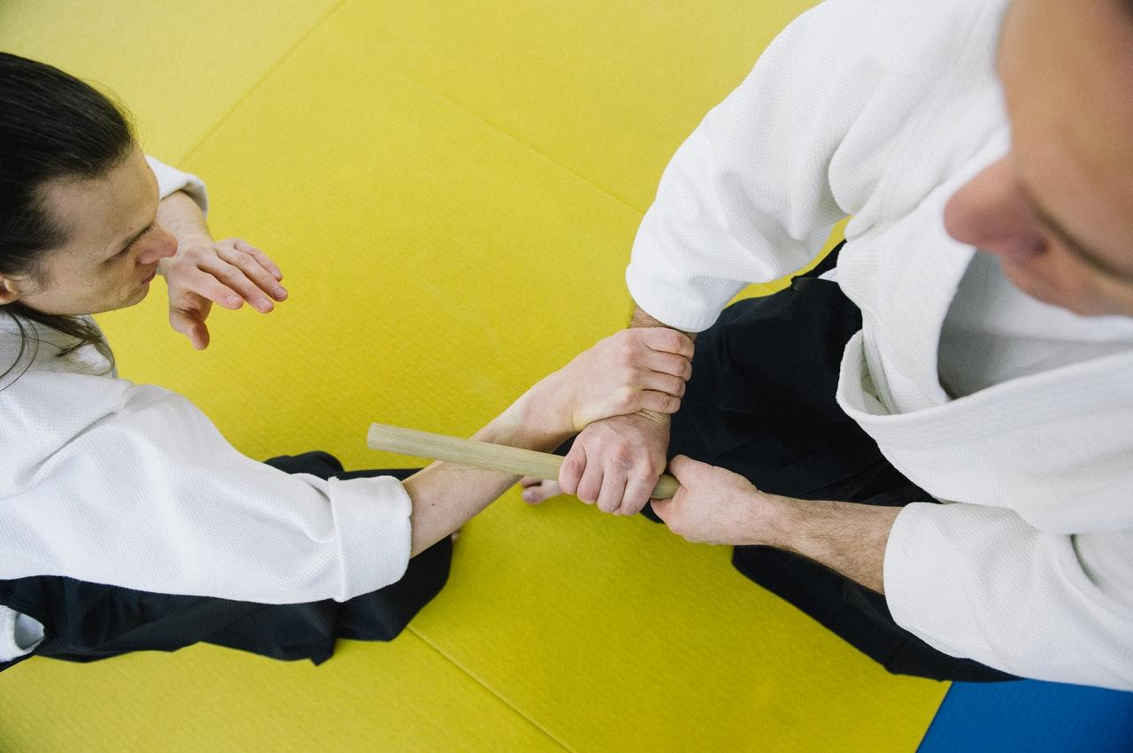

Nothing is more empowering than being able to protect yourself. Many people think that self-defence training is just preparation for any untoward incident. The truth is: it offers a lot more. Here are the other benefits you can get from learning self-defence:

## 1. Confidence Boost

You’ll learn a lot of things in self-defence classes. These include how to detect malicious behaviour, dodge an attack, and effectively subdue the enemy. Learning how to protect yourself and others can give a sense of accomplishment, boosting your confidence. Self-defence training can help you discover the capabilities you’re not aware of.

*“Enrolling in a martial arts class hits multiple targets with one stone. You learn new things while gaining more confidence, more self-respect, and more self-discipline. It’s also a good exercise for all ages. Plus, it’s an honour to practice a 2000-year-old sport.”,* shares Joshua Bennett of [Losing Weight Fast](https://losingweightfast.com.au/weight-loss-programs/).

## 2. Promotes Balance

Some of us can’t efficiently do two things at the same time, particularly with activities that require a lot of balance and coordination. Self-defence classes help you gain more control over your body to achieve a single goal. It begins with sharpening your focus. Once you learn how to be more focused, you’ll be surprised at how much you can achieve.

## 3. Enforces Self-Discipline

To master various self-defence techniques, you need to work on self-discipline. There will be days when you’d too tired to practice or follow the rules, but you’d realise that excellence is not easily achieved. Self-discipline is developed when you force yourself to show up to class and set aside the things that are not relevant to your goals. Just like any other item in this world, only practice can make you better.

Here are other tricks to [master self-discipline](https://www.entrepreneur.com/article/287005).

## 4. Teaches Trust and Self-Respect

All forms of self-defence training, such as Taekwondo, gravitate towards trust and respect. They unveil your capabilities as a person so that you learn to trust yourself. At the same time, they teach you that it is only through self-belief that one can accomplish an excellent task.

Respect is a significant value in any martial arts. From coming on time and wearing the proper uniform to bowing to your masters and accepting defeat—respect is ever-present. Self-defence training also emphasises the power of respect in avoiding conflict so that there will be no need to harm each other.

## 5. An Excellent Physical Activity

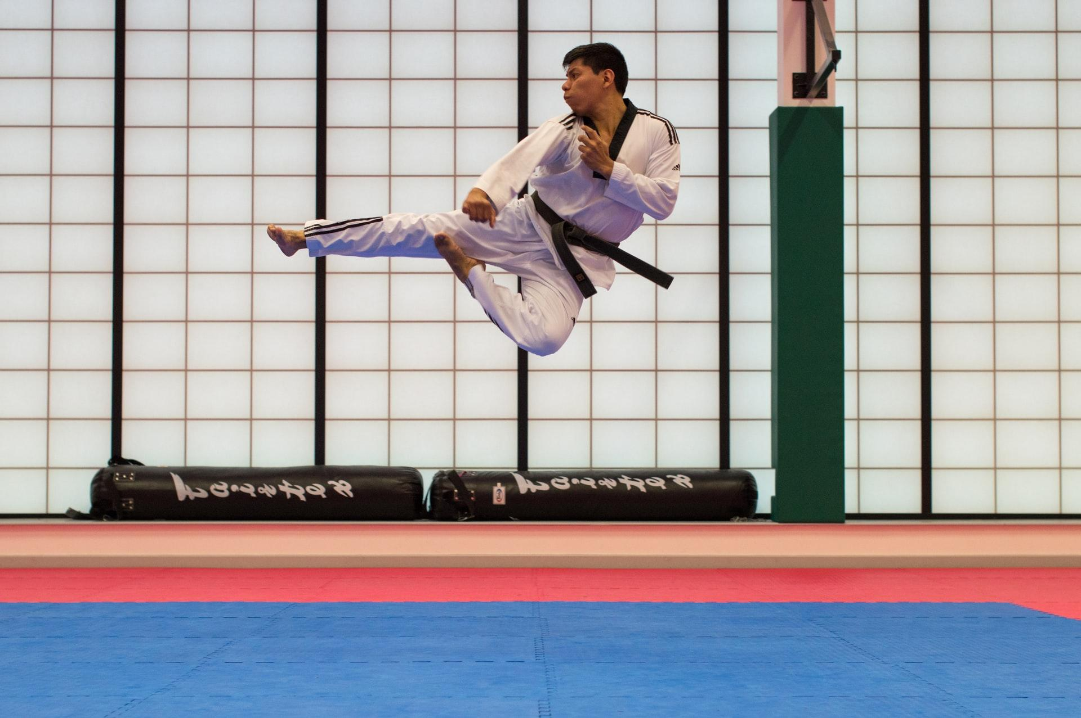

Whatever martial art you pursue, it’s better than sitting on a couch and watching TV all day. In Taekwondo, for example, your flexibility and agility will be improved because it involves a lot of high kicks, jump-spinning kicks, and fast kicking techniques. It improves blood circulation and strengthens the heart with intensive aerobic and anaerobic activities. You’ll struggle initially, but it’ll get better as your body gets used to training.

The [Institute of Modern Tae Kwon Do](https://imt.org.au/) offers self-defence classes to all ages. Our instructors can modify the lessons accordingly. Enrol now and be surprised what you can do!