NSW Sport and Recreation Centre

Myuna Bay

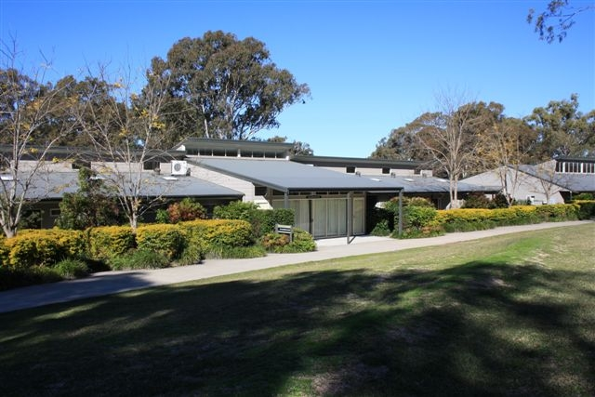

Weekend and Short Break Holidays



www.dsr.nsw.gov.au/myunabay

Information

Thank you for choosing to stay at Myuna Bay. In preparation for your visit, please read on for an A to Z of information to help you make the most of your stay.

In this pack:-
- Accommodation
- Arrival
- Car parking
- Departure
- Facilities
- Instructors for hire
- Meals
- Room amenities
- Safety
- Phones
- What to Bring
- Rubbish
- Directions
- Centre Map

Myuna Bay sport and Recreation Centre is 1½ hours from Sydney and ½ hour from the Central Coast, and approximately 45 minutes from Newcastle.

Our Centre occupies 156 hectares so you are assured of a true getaway! The relaxed nature of Myuna Bay allows you to be as active or a laid back as you like

Whether you choose to do your own thing, or have us plan a schedule of activities for you, our weekend and shortbreak holidays offer great times and great value.

Your fees include accommodation, meals and the use of shared facilities’ such as the pool, tennis courts, beach volleyball, cricket nets and oval areas.

Myuna Bay Centre has a two night minimum stay or 3 nights over long weekends.

If you have any further questions after receiving this information package, please feel free to call the centre for more details on (02) 4973 33301.

Accommodation
Your group has booked our lodge accommodation, which can sleep up to 250 people. Each lodge building features a total of 10 – 16 bedrooms:

- Rooms of 2 – 6 persons with ensuite
- Large enclosed common area with TV’s /DVD’s
- Lodges have reverse cycle air conditioning and gas heating
- Laundry facilities
- Tea room / kitchen facilities
- Covered Verandahs

If you haven’t booked the whole centre, it is possible you will be sharing with another group. This is a very regular occurrence at Myuna Bay and we are very experienced in catering for multiple groups.

Arrival
Guests are requested to visit the office on arrival to the centre were centre staff will greet you and be on hand to answer questions.

Arrival time is 4pm for weekend groups, and at the discretion of the Centre for mid week arrival.

Car Parking
Cars can be left in the main parking area at Myuna Bay Centre or at the lodge car parking areas.

Departure
Departure time is 4pm for weekend groups, or at the discretion of the Centre for mid week departures.

Facilities
Guests are welcome to use the Centre share facilities’: swimming pool, tennis courts, mini golf, cricket nets, oval playing area and bushwalking tracks around and within the Centre.

Please note : Myuna Bay Centre pool is open October until May.

Instructors for hire
If you would like to take part in activities like canoeing, kayaking, flying fox, giant swing, abseiling and more, you can book an instructor for $25.00 / day / person (min. group of 20 and max. group of 30 participants).

Please note: instructors must be booked four weeks in advance of your stay. All activities are conducted by qualified staff that have undergone the Working with Children Check.

Each visitor participating in group activities must complete a Medical and Consent form. Group leaders should collect these and hand them to centre staff on arrival,

Instructor Activity list:
7 years and over : 10 years and over
Climbing Wall Abseiling
Flying Fox High Rope Challenge
Giant Swing Raft Building
Low Ropes Challenge Sailing
Canoeing / kayaking
Archery
Boomerangs
Pool Games
Cookout

Meals
Our catering team will prepare a variety of delicious meals for your group. We can cater for special dietary needs – just notify us two weeks prior to your arrival.

Groups are generally required to help with serving/cleaning duties at meal times, if you would like these services to be provided for you, please let us know. An additional charge will apply.

Meal times : B/fast - 8am
Lunch – 12.30pm
Dinner – 6pm

Day Visitors
Any person attending over the agreed number (i.e., day visitors) will incur an additional charge of $12.00 / day / person + casual meal cost (if applicable)

Conference Equipment
Conference equipment can be hired from the Centre, please speak with the Administration Staff.

Room Amenities
Each room has:
- 2 – 6 beds (bunks style)
- Pillows
- Storage area for your belongings
- Ensuite bathroom

Safety / Security
The safety of our visitors is of highest priority, so Myuna Bay Centre has installed security boom gates along with CCTV camera. Your group will be issued with the boom gate access number with the final package, after the Security deposit has been paid.

To ensure your stay is safe and enjoyable:
- A 24 hour on call liaison officer will be provided for your group throughout your stay.
- Instructors are fully qualified in all centre activities, and have undergone the Working with Children Check.
- Instructors are trained in first aid & Resuscitation.

Telephone and mobile phones
A coin operated telephone is available for guests on the office verandah.

Mobile phone reception at Myuna Bay Centre is good.

Rubbish Collection
Please ensure all your rubbish is placed in the bins provided, Centre staff will do a daily collection from your lodge.

Alcohol consumption
Myuna Bay Centre will accept sensible consumption of alcohol in designated areas, or lodges.

For safety reasons, people may not be allowed to participate in certain activities if they have been drinking.

Smoking
Smoking is not permitted in any building, sleeping areas or outdoor eating areas. Please smoke in dedicated smoking areas only.

Pets
Pets are not permitted at Myuna Bay Centre.

Things to bring
- Insect repellent
- Torch
- Sunscreen and hats
- Towels and bed linen including doona/blankets
- Toiletries
- A jumper / sweatshirt (year –round.)

Contact Details

Phone: (02) 4973 3301
Fax : (02) 4970 5014

Email: myuna.bay@communities.nsw.gov.au

Directions
Myuna Bay Sport and Recreation Centre is located on the shores of Lake Macquarie, about 90 minutes drive north of Sydney and 40 minutes south of Newcastle.
Myuna Bay from Sydney
- Follow the F3 freeway north to the Morisset/ Cooranbong exit
- Turn right and continue through Morisset and past Dora Creek
- The Centre is approximately 12 kilometres from the freeway on the right hand side of the road.
Myuna Bay from Newcastle
- Follow the F3 freeway south and take the Morisset exit
- Turn left and continue through Morisset and past Dora Creek
- The Centre is approximately 12 kilometres from the freeway on the right hand side of the road

